MLA0105 - Artificial Intelligence and Expert Systems for Gaming
Experiment 1: 8 Puzzle Problem
Code:
from collections import deque
goal_state = [[1, 2, 3],
[4, 5, 6],
[7, 8, 0]]
def find_zero(state):
for i in range(3):
for j in range(3):
if state[i][j] == 0:
return i, j
def copy_state(state):
return [row[:] for row in state]
def get_next_states(state):
x, y = find_zero(state)
moves = []
directions = [(1,0), (-1,0), (0,1), (0,-1)]
for dx, dy in directions:
nx, ny = x + dx, y + dy
if 0 <= nx < 3 and 0 <= ny < 3:
new_state = copy_state(state)
new_state[x][y], new_state[nx][ny] = new_state[nx][ny], new_state[x][y]
moves.append(new_state)
return moves
def solve_puzzle(start):
visited = set()
queue = deque([(start, [])])
while queue:
state, path = queue.popleft()
state_tuple = tuple(map(tuple, state))
if state_tuple in visited:
continue
visited.add(state_tuple)
if state == goal_state:
return path + [state]
for nxt in get_next_states(state):
queue.append((nxt, path + [state])
return None
start_state = [[1, 6, 5],[7, 3, 8],[4, 2, 0]]
result = solve_puzzle(start_state)
if result:
print("Solution found in", len(result)-1, "moves:\n")
for step in result:
for row in step:
print(row)
print()
else:
print("No solution exists!")
Output:
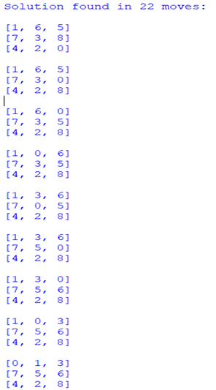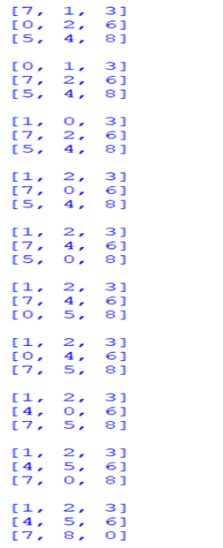

Experiment 2: Towers of Hanoi problem

Code:
def towers_of_hanoi(n, source, auxiliary, destination):
if n == 1:
print(f"Move disk 1 from {source} → {destination}")
return
towers_of_hanoi(n - 1, source, destination, auxiliary)
print(f"Move disk {n} from {source} → {destination}")
towers_of_hanoi(n - 1, auxiliary, source, destination)
num_disks = int(input("Enter number of disks: "))
towers_of_hanoi(num_disks, 'A', 'B', 'C')
Output:

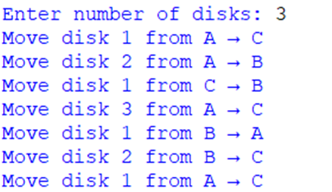

Experiment 3: Breadth-First Search (BFS)

Code:
from collections import deque
graph = {
0: [2, 1, 3],
1: [0],
2: [0, 4],
3: [0],
4: [2]
}
def bfs(start):
visited = set()
queue = deque([start])
print("BFS Traversal Order:")
while queue:
node = queue.popleft()
if node not in visited:
print(node, end=" ")
visited.add(node)
for neighbor in graph[node]:
if neighbor not in visited:
queue.append(neighbor)bfs(0)
Output:
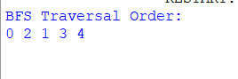

Experiment 4: Monkey and Banana Problem

Code:
monkey_pos = "door"
box_pos = "window"
banana_pos = "middle"
monkey_on_box = False

def print_state(action):
print(f"Action: {action}")
print(f" - Monkey position: {monkey_pos}")
print(f" - Box position: {box_pos}")
print(f" - Monkey on box: {monkey_on_box}")
print("--------------------------------------")

monkey_pos = box_pos
print_state("Monkey walks to the box")

box_pos = banana_pos
monkey_pos = box_pos
print_state("Monkey pushes the box under the bananas")

monkey_on_box = True
print_state("Monkey climbs on the box")

if monkey_on_box and box_pos == banana_pos:
print("🎉 Monkey got the bananas! 🐒🍌")

else:
print("Monkey failed to get the bananas.")
Output:
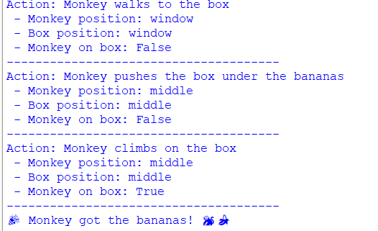
Experiment 5: 8 x 8 Chessboard Problem

Code:
N = 8
def print_board(board):
for row in board:
print(" ".join(row))
print("\nSolution completed!")
def is_safe(board, row, col):
for i in range(row):
if board[i][col] == "Q":
return False
i, j = row, col
while i >= 0 and j >= 0:
if board[i][j] == "Q":
return False
i -= 1
j -= 1

i, j = row, col
while i >= 0 and j < N:
if board[i][j] == "Q":
return False
i -= 1
j += 1
return True
def solve_queens(board, row):
if row == N:
print_board(board)
return True
for col in range(N):
if is_safe(board, row, col):
board[row][col] = "Q" # Place queen
if solve_queens(board, row + 1):
return True
board[row][col] = "." # Backtrack
return False
board = [["." for _ in range(N)] for _ in range(N)]
solve_queens(board, 0)
Output:
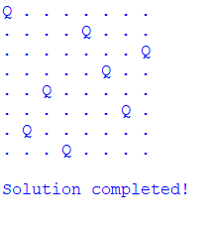
Experiment 6: Depth-First Search (DFS) Problem

Code:
def dfs(graph, start, visited=None):
if visited is None:
visited = set()
visited.add(start)
print(start, end=" ")
for neighbour in graph[start]:
if neighbour not in visited:
dfs(graph, neighbour, visited)
graph = {
5: [3, 7],
3: [2, 4],
7: [8],
2: [],
4: [],
8: []
}
print("DFS Traversal starting from node 5:")
dfs(graph, 5)
Output:
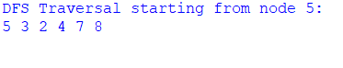

Experiment 7: Water Jug Problem

Code:
from collections import deque

def water_jug():
visited = set()
queue = deque()
queue.append((0, 0))
visited.add((0, 0))

while queue:
a, b = queue.popleft()
print(f"Jug4 = {a} Jug3 = {b}")

if a == 2:
print("\nReached 2 gallons in the 4-gallon jug!")
break

next_states = [
(4, b),
(a, 3),
(0, b),
(a, 0),
(a - min(a, 3 - b), b + min(a, 3 - b)),
(a + min(b, 4 - a), b - min(b, 4 - a)),
]

for state in next_states:
if state not in visited:
visited.add(state)
queue.append(state)
water_jug()

Output:
